Verkætlan 2023
Høvuðsevni:
Gerðir og fylgir
Hugarok um partsevni:
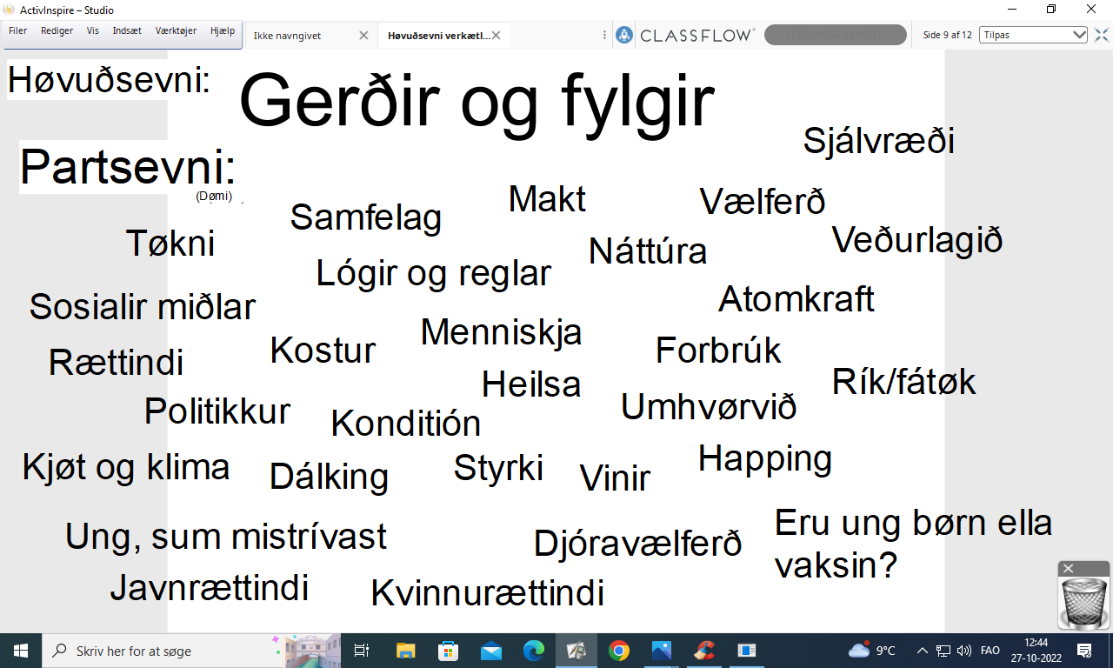
Bólkar:
- Anita, Halla, Maria H, Sofía
- Anna, Katrin, Margret
- Barbara, Marta, Miriam, Saranja
- Brá, Ida Maria, Rita, Sólrun
- Elna, Sandra, Sára
- Heiðrun, Kristina, Maria S, Rannvá
- Karin, Monica, Silvia
- Bjørk, Levi, Lydia
- Agnar, Hanus S, Rókur, Stefan
- Atli, Benjamin, Daniel, Elias
- Bartal, Gilli, Theodor D
- Hanus G, John, Jógvan Elias, Regin, Samuel

